*What did you find most interesting about the article?*

*What questions do you have about anything you read in the article?*

*Are the various definitions of fairness described in the article sufficient? Can you think of other ways to define fairness in such contexts?*

*What do you think about the conclusions of the article?*

*How do some of the issues of fairness potentially apply to other uses of AI techniques that we learned about in CS 131?*

Recommender systems influenced by raw algos

KNN, sparse matrix, tensor factorization, deep learning

Or customers inputs – conflict of interest

Fairness issue

Free

You are the product

Google, facebook, amazon

Fairness – cant be defined

Will differ per government and society values nation to nation, group to group

Fairness probably means using an algo without any personalization

Which will not be valuable vs competitors

Lower engagement, less attention on product, could go out of business

Big trenches come from vast amounts of data

And also highly custom recommender systems – FAANG

If you are to recommend popular things

Up and coming artists for example might not get exposure

Marginalized groups too potentially

Visual image recommendation systems

Easy to divide by race

Protected group vs unprotected

Divisive by nature

Harder to judge class - $

Job recommendations

Similar to A\* Star Search – shortest path is most qualified candidate

Can lead to certain groups getting overlooked

Will likely favor people with jobs already as opposed to people unemployed

Interviews

Not always fair – certain conventions have shortcut interviews

To increase workplace diversity

Is this fair to handicap non-URM people – maybe? To counter privilege etc

But the question of fairness emerges again

Fairness probably against shareholder desires

ESG score – Bloomberg stocks etc

Can alter shareholder incentives from pure profit

To “profit for good”

Driver fairness

Recommending trips to wealthier districts in city (may tip better)

Could be biased and ensure faster delivery to the wealthy

Could hurt less well-off parts of city with delivery time and priority

Rating customers and drivers

Biases could impact rating

Rating is likely to influence who you choose for a trip

Reinforcement cycle

WYSIWYG

I don’t think this exists in any modern recommender system that’s non-academic

Always under the hood tunings etc

Instagram twitter etc

Exception: TV ads are non-targeted to the home afaik

Not very effective at conversion

Does target typical viewer audience of a channel though

WAE

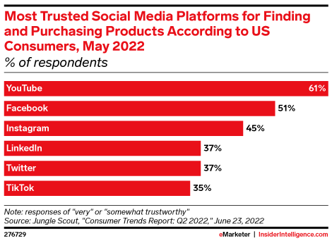

<https://www.insiderintelligence.com/content/consumers-trust-youtube-most>

Youtube – very personalized

Also higher trust – authentic

Could be coming from people in videos with partnerships that explain product rather

than one-size-fits-all approach of an advertiser